Homework #2

# Complete the Review Assignment in chapter Tutorial 1 DUE: Fri Oct 6 11:59pm

Instructions:   
Complete **Review Assignment in Tutorial 1 on** pp71-73 in the hard copy of the book (and some e-books), and section 1-24a in the MindTap e-text. There may be a typo in Step 19. To fix it, change the word ***article*** to ***aside*** in the first line of the step. That is, it should now read, *“Within the****aside****element, do the following*”. Please note that aside element is nested inside article element.

Use Komodo Edit or other editor of your choice. Use the files in the folder called data files/html01/review. (data files: mp_index_txt.html, mp_menu_txt.html, p_events_txt.html, etc.) Before you start, it is a good idea to make a copy of the tutorial folder so that you have the original files just in case you need them.

After completing Review Assignment for Tutorial 1, rename its folder called review to **review1_yourlastname**. Be sure all original and modified files are in the folder. Zip, and drop it into **Review Assignment 1 Drop Box** in Brightspace. (Note: There is a simulation coding exercise of the **Review Assignment** in the Cengage MindTap course, but you will not be doing that. And besides MindTap is not required.)

See next page for instructions on the use of various textbook versions

Instructions for using various textbook versions

MindTap e-book:

To access Tutorial 1 in MindTap, click on the e‑book section link called:

**Tutorial 1: Getting Started with HTML5**

Below it, click on the link called:

Tutorial 1 Read.

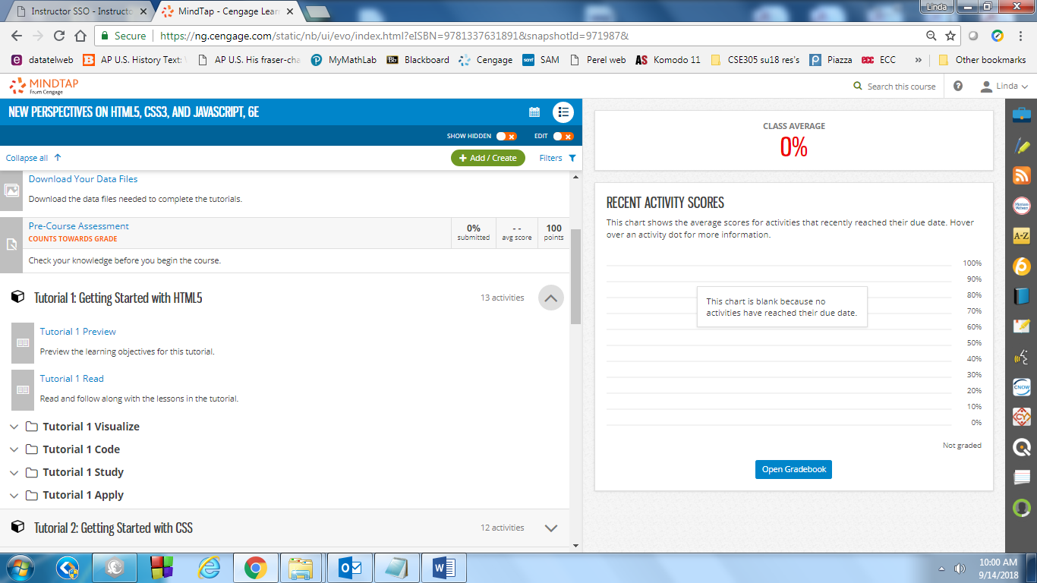

Once you are in Tutorial 1 in MindTap you will see a link in the top left corner that gets you back to a chapter “Table of [Contents](javascript://)”. Use this link to jump around the chapter, or use the previous and next page arrows. To leave the chapter, click the X in the top right corner.

in some e-book versions of our textbook, (but not MindTap) you can enter the page numbers into the box on the screen to go to that page directly. For example, enter HTML65 to go to page 65 and enter HTMLA3 to go to Appendix A, p3. As well you can use a Table of Contents to navigate.